FREQUENTLY ASKED QUESTIONS

Question: What algorithm is used to determine the timeframes on accepting and completing assignments?
Answer: The timeframes used to populate the “Expected Completion Date” are based off of the guidelines provided to each vendor company. Please refer to the provided guidelines for more information.
Administrative Assistance

For further information regarding Frontline’s expectations, policies and procedures, please contact the Vendor Department Coordinator.

Question: When can the “Report a Delay” function be used?
Answer: The “Report a Delay” function can be used in situations where you have prior knowledge that the assignment cannot be completed within Frontline’s expected timeframe.

Question: How can I check payment status for a specific claim?
Answer: Within the “Invoices” tab of the Vendor Portal you will see all the invoices that have been submitted for that specific file. There is also a column listed that informs you of the date and time the check has been issued.
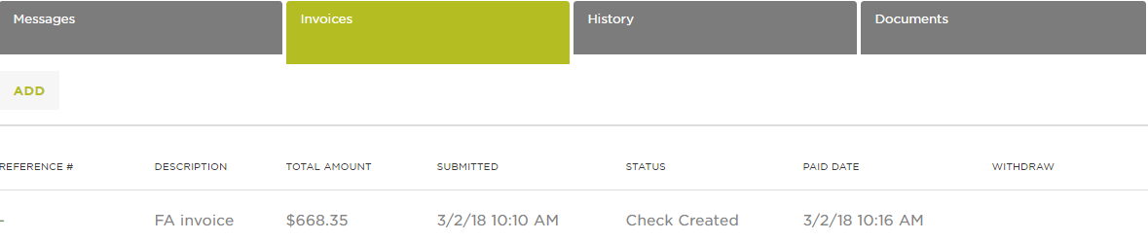

Questions: If there is an issue on a file, how am I to communicate with the assigned Frontline Adjuster?
Answer: All email correspondence must go to dailyreports@flhi.com, no emails are to go to the individual adjusters. The “Service Request Details” provides information on the primary adjuster.

